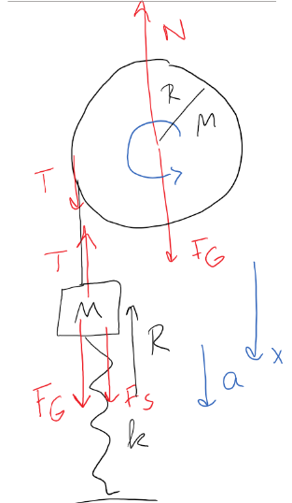
Test Preparation Homework #3: Solution
1.
$$\text{Bloc}\text{k}\text{:} \begin{matrix}\sum{ }F_{x}= & T_{x}+F_{Gx}+F_{Sx}=Ma_{x} \\ & -T+Mg+kR=Ma_{x}\end{matrix}$$
Pulley: $Στ_{z}=τ_{Nz}+τ_{Gz}+τ_{Tz}=Iα_{z}$
No slip: $a=αR$
Note: z-axis and $x$ - $ax$ should count same motion as positive.
$$\begin{matrix} & TR=\frac{1}{2}MR^{2}α_{z} \\ & T=\frac{1}{2}Ma \\ & Mg+rR=Ma+\frac{1}{2}Ma \\ & a=\frac{2}{3}\frac{Mg+kR}{M}\end{matrix}$$

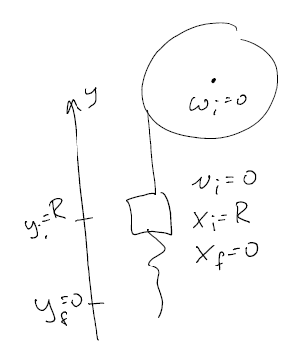
1b
$\begin{matrix}E_{f}-E_{i}= W_{other} \\ E_{i}=E_{f} \\ \frac{1}{2}Mv_{i}^{2}+\frac{1}{2}Iω_{i}^{2}+Mg{gy}_{i}+\frac{1}{2}kx_{i}^{2}= \\ \frac{1}{2}Mv_{f}^{2}+\frac{1}{2}Iω_{f}^{2}+Mgy_{f}+\frac{1}{2}kx_{f}^{2} \\ No slip: v=ωR \\ MgR+\frac{1}{2}rR^{2}=\frac{1}{2}Mv_{f}^{2}+\frac{1}{2}\left(\frac{1}{2}MR^{2}\right){\left(\frac{v_{f}}{R}\right)}^{2} \\ =M\left(\frac{1}{2}+\frac{1}{4}\right)v_{f}^{2}\end{matrix}$

$$V_{f}=\sqrt{\frac{4}{3}\frac{MgR+\frac{1}{2}kR^{2}}{M}}$$
2. 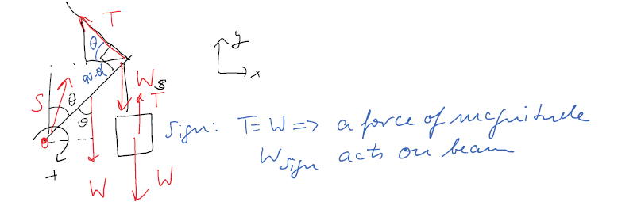

$$\begin{matrix} & \sum{ }τ_{z}=τ_{S_{z}}+τ_{W_{z}}+τ_{W_{s_{z}}}+τ_{T_{z}}=0 \\ & +\frac{W\frac{L}{2}}{sin⁡θ}+WLsin⁡θ-TL\underset{1}{\underbrace{sin⁡{90}^{∘}}}=0 \\ & \begin{matrix}\frac{3}{2}Wsin⁡θ & =T \\ \sum{ }F_{x}= & S_{x}+W_{x}+W_{s_{x}}+T_{x}=0 \\ S_{x}-Tcos⁡θ & =0\end{matrix} \\ & S_{x}=Tcos⁡θ=\frac{3}{2}Wsin⁡θcos⁡θ \\ \sum{ }F_{y}= & S_{y}+W_{y}+W_{sy}+T_{y}=0 \\ & S_{y}-2W+\operatorname{Tsin}{θ}=0 \\ & S_{y}=2W-Tsin⁡θ\end{matrix}$$

9.(30) A entrance gate into a petting zoo has mass $M$ and width $L$. It is pivoted at point $P$ that is $1/4L$ from one end. A parent has just gone through the gate and it is swinging back. A child of mass $2M$ enters the zoo by leaping onto the gate with speed $V$ and angle $θ$ at a point that is $3/4L$ from its end. Just before the child hits and clings to it, the gate's angular speed is $ω_{o}$ as shown in the diagram. The moment of inertia of the gate about its center of mass is $1/12ML^{2}$ and about an end it is $1/3ML^{2}$.
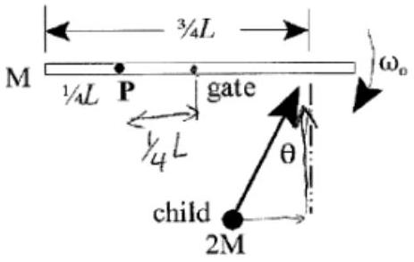

a) What is the moment of inertia of the gate about its pivot $P$ ?
$$\begin{matrix}I_{P} & =I_{CM}+Md^{2}=\frac{1}{12}ML^{2}+M{\left(\frac{1}{4}L\right)}^{2}=\left(\frac{1}{12}+\frac{1}{16}\right)ML^{2} \\ & =\left(\frac{4}{48}+\frac{3}{48}\right)ML^{2}=\frac{7}{48}ML^{2}\end{matrix}$$
b) Derive an expression of the angular speed of the gate-child system just after the child has leaped onto it.
$$\begin{matrix}τ_{\text{nel} }=0→L=L_{fz} \\ I_{i}ω_{o_{z}}-2MV\frac{1}{2}Lcos⁡θ=I_{f}ω_{fz} \\ \frac{7}{48}ML^{2}ω_{0}-2MV\frac{1}{2}Lcos⁡θ=\underset{\frac{31}{48}ML^{2}}{\underbrace{\frac{7}{48}ML^{2}+2M{\left(\frac{1}{2}L\right)}^{2}}})ω_{f_{z}} \\ ω_{f}=\frac{\frac{7}{48}ML^{2}ω_{0}-MVLcos⁡θ}{\frac{31}{48}ML^{2}}=\left|\frac{7Lω_{0}-48Vcos⁡θ}{31L}\right|\end{matrix}$$

